August-November 2024
CS616: Statistical Pattern Recognition
CS612: Statistical Pattern Recognition Laboratory
Programming Assignment 4 Report

Submitted by Group 03

Pawan Ram Mali (PhD) | Abhishek Sharma (MS) | Sachin Maurya (MS)
Department of CSE  Indian Institute of Technology | Department of CSE  Indian Institute of Technology | Department of CSE  Indian Institute of Technology
Dharwad, India | Dharwad, India | Dharwad, India
cs24dp011@iitdh.ac.in | cs24ms003@iitdh.ac.in | cs24ms002@iitdh.ac.in

Contents
I. Introduction 5
A. Overview of the Assignment and Objectives 5
B. Datasets Description 5
Dataset 1: 2-dimensional artificial data 5
Dataset 2: 3-class scene image dataset 5
II. Dataset 1: 2-Dimensional Artificial Data 6
A. Methodology 6
1. Bayes Classifier Using KNN Density Estimation 6
2. Fisher Linear Discriminant Analysis (FDA) 6
3. Perceptron-Based Classifier 6
4. Logistic Regression Classifier 6
5. SVM-Based Classifier 6
B. Results and Analysis 7
1. Classifier Performance Metrics 7
2. KNN-Based Bayes Classifier Analysis 7
3. FDA Analysis 7
4. Perceptron Analysis 7
5. Logistic Regression Analysis 7
6. SVM Analysis 7
C. Comparative Analysis 8
1. Decision Region Plots 8
2. Special Comparisons 8
III. Dataset 2: 3-Class Scene Image Dataset 9
A. Methodology 9
1. Bayes Classifier Using GMM 9
2. Bayes Classifier Using KNN 9
3. FDA Implementation 9
4. Perceptron Implementation 9
5. Logistic Regression Implementation 9
6. SVM Implementation 9
B. Results and Analysis 9
1. Classifier Performance Metrics 9
2. GMM Analysis 9
3. KNN Analysis 10
4. FDA Performance 10
5. Perceptron and Logistic Regression Results 10
6. SVM Results 10
C. Dimensionality Reduction Analysis 10
1. PCA Analysis 10
2. FDA Analysis 10
IV. Overall Comparative Analysis 11
A. Cross-Assignment Comparison 11
V. Conclusion 12
A. Key Findings 12
B. Best Performing Methods 12
C. Analysis Insights 12
VI. References 13

List of Figures

Figure 1 GMM based Classifier Decision Regions for different number of components 7
Figure 2 GMM Cluster centers for different GMM components 8
Figure 3 KNN Decision Regions 9
Figure 4 Original Space & Projected Space in FDA 10
Figure 5 Perceptron Decision Regions 11
Figure 6 Logistic Regression Decision Regions 11
Figure 7 SVM Decision Regions 12
Figure 8 SVM Decision Regions 13
Figure 9 GMM Based Classifier Decision Regions for Components 1 to 8 15
Figure 10 GMM Based Classifier Decision Regions for Components 16 16
Figure 11 GMM Cluster centers for GMM Components 1 to 2 17
Figure 12 GMM Cluster centers for GMM Components 4 to 8 18
Figure 13 GMM Cluster centers for GMM Components 16 19
Figure 14 FDA 1D Projection 19
Figure 15 Perceptron Decision Boundary 20
Figure 16 Logistic Regression Decision Boundary 20
Figure 17 SVM Linear Decision Boundary 21
Figure 18 SVM Polynomial Decision Boundary for Degree = 2 22
Figure 19 SVM Polynomial Decision Boundary for Degree = 3 23
Figure 20 SVM Polynomial Decision Boundary for Degree = 4 24
Figure 21 SVM RBF Decision Boundary (gamma =0.01) 25
Figure 22 SVM RBF Decision Boundary (gamma =0.1) 26
Figure 23 SVM RBF Decision Boundary (gamma =1) 27

I. Introduction

A. Overview of the Assignment and Objectives
This assignment aims to apply statistical pattern recognition techniques to two datasets: a 2D artificial dataset and a 3-class scene image dataset. The primary objectives are:
- Implementation of classifiers, including Bayes classifier, KNN-based density estimation, FDA, perceptron, logistic regression, and SVM with various kernels.
- Evaluation of classifier performance using metrics such as accuracy, precision, recall, and F-measure.
- Visualization and analysis of decision boundaries, dimensionality reduction techniques, and cross-method comparisons.

B. Datasets Description

Dataset 1: 2-dimensional artificial data
  - Contains two subsets:
    - Linearly separable dataset: Suitable for evaluating classifiers with linear decision boundaries.
    - Nonlinearly separable dataset: Tests classifiers' abilities to handle non-linear relationships.

Dataset 2: 3-class scene image dataset
  - Represented as 32-dimensional Bag-of-Visual-Words (BoVW) features derived from images.
  - Requires dimensionality reduction (e.g., PCA) to manage high dimensionality.

II. Dataset 1: 2-Dimensional Artificial Data

A. Methodology

1. Bayes Classifier Using KNN Density Estimation
- Experimented with different KKK values (e.g., K=1,3,5,7K=1, 3, 5, 7K=1,3,5,7).
- Implementation details:
  - Density estimation was performed using KNN for both datasets.
  - Decision boundaries were visualized to analyze the impact of KKK on classification performance.

2. Fisher Linear Discriminant Analysis (FDA)
- Implemented FDA to reduce data dimensionality and trained Bayes classifiers:
  - Using unimodal Gaussian densities.
  - Using GMMs with varying numbers of mixtures.

3. Perceptron-Based Classifier
- Implementation:
  - Trained perceptron using a standard update rule on linearly and nonlinearly separable datasets.
- Training focused on convergence and robustness against non-linearity.

4. Logistic Regression Classifier
- Applied a gradient-descent approach to optimize parameters.
- Regularization techniques were explored to prevent overfitting.

5. SVM-Based Classifier
- Implemented SVM using:
  - Linear kernel.
  - Polynomial kernel with varying degrees.
  - Gaussian/RBF kernel with different bandwidth parameters.
- Parameters were tuned to optimize performance for both linear and non-linear datasets.

B. Plot Visualizations for Linearly Separable Dataset

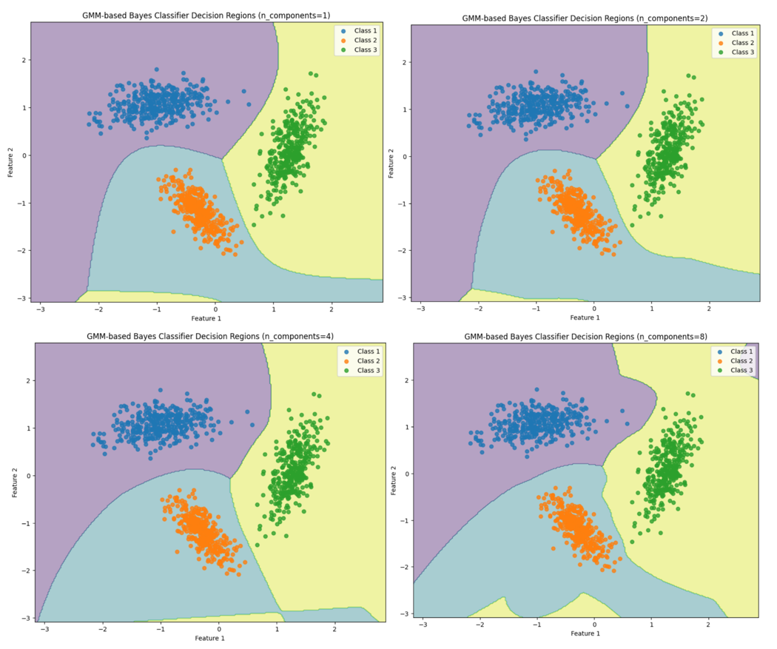
Figure 1 GMM based Classifier Decision Regions for different number of components

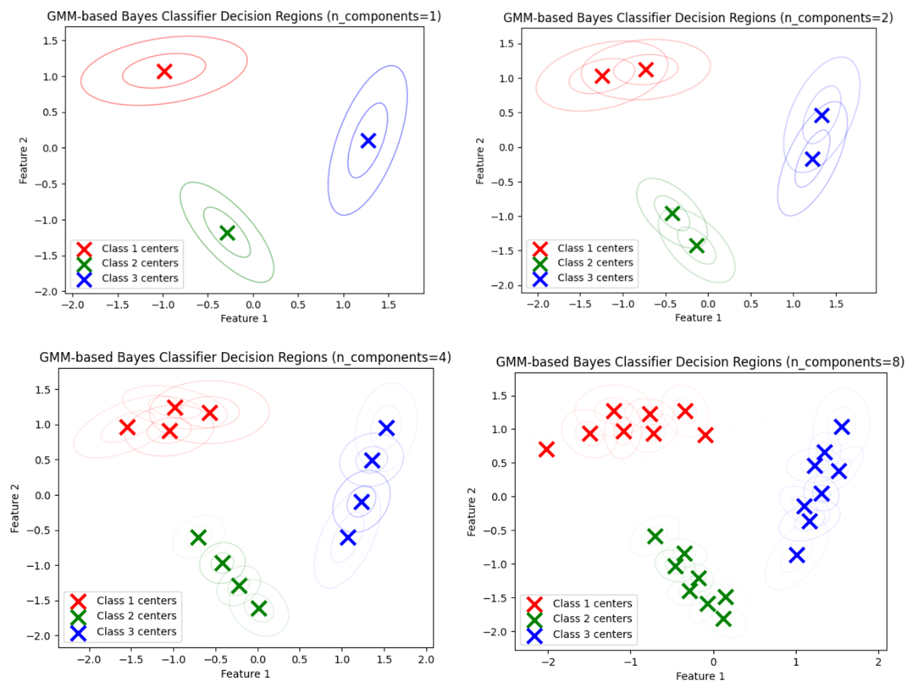
Figure 2 GMM Cluster centers for different GMM components
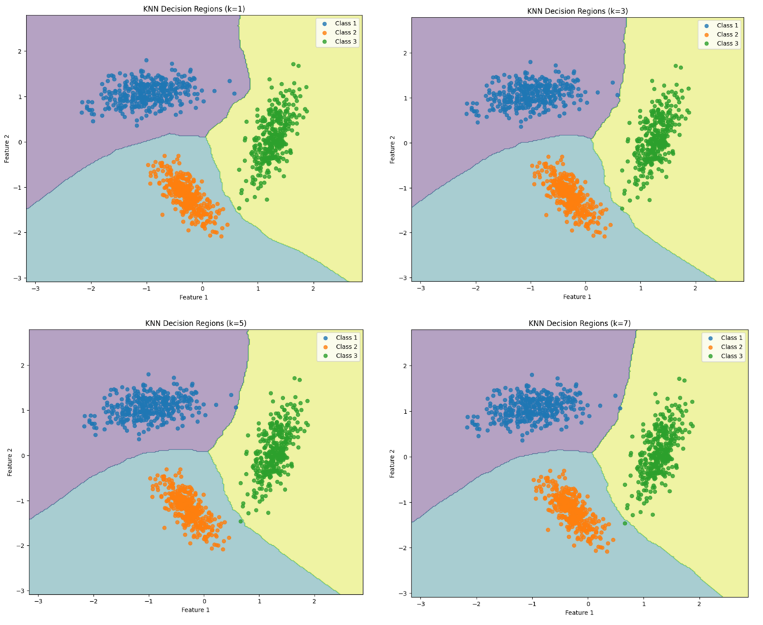
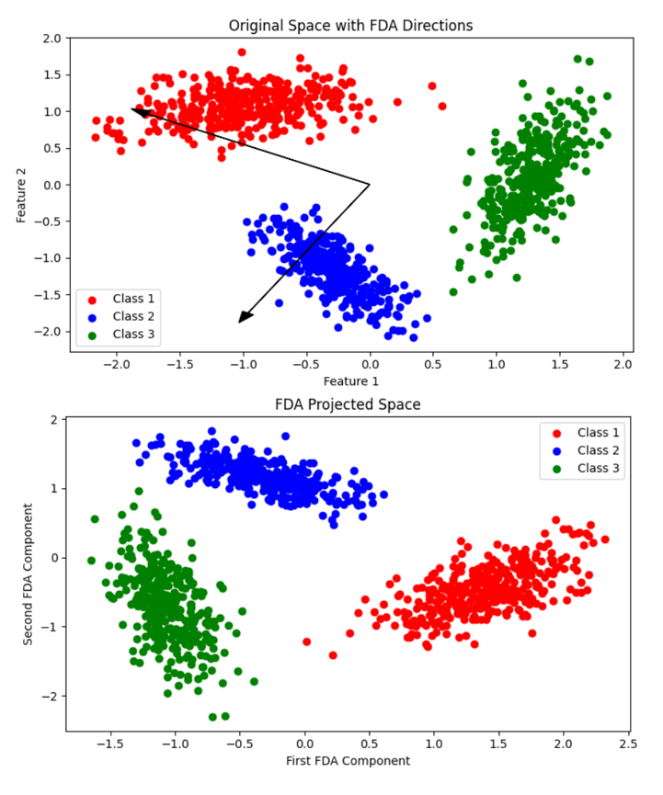
Figure 3 KNN Decision Regions
Figure 4 Original Space & Projected Space in FDA
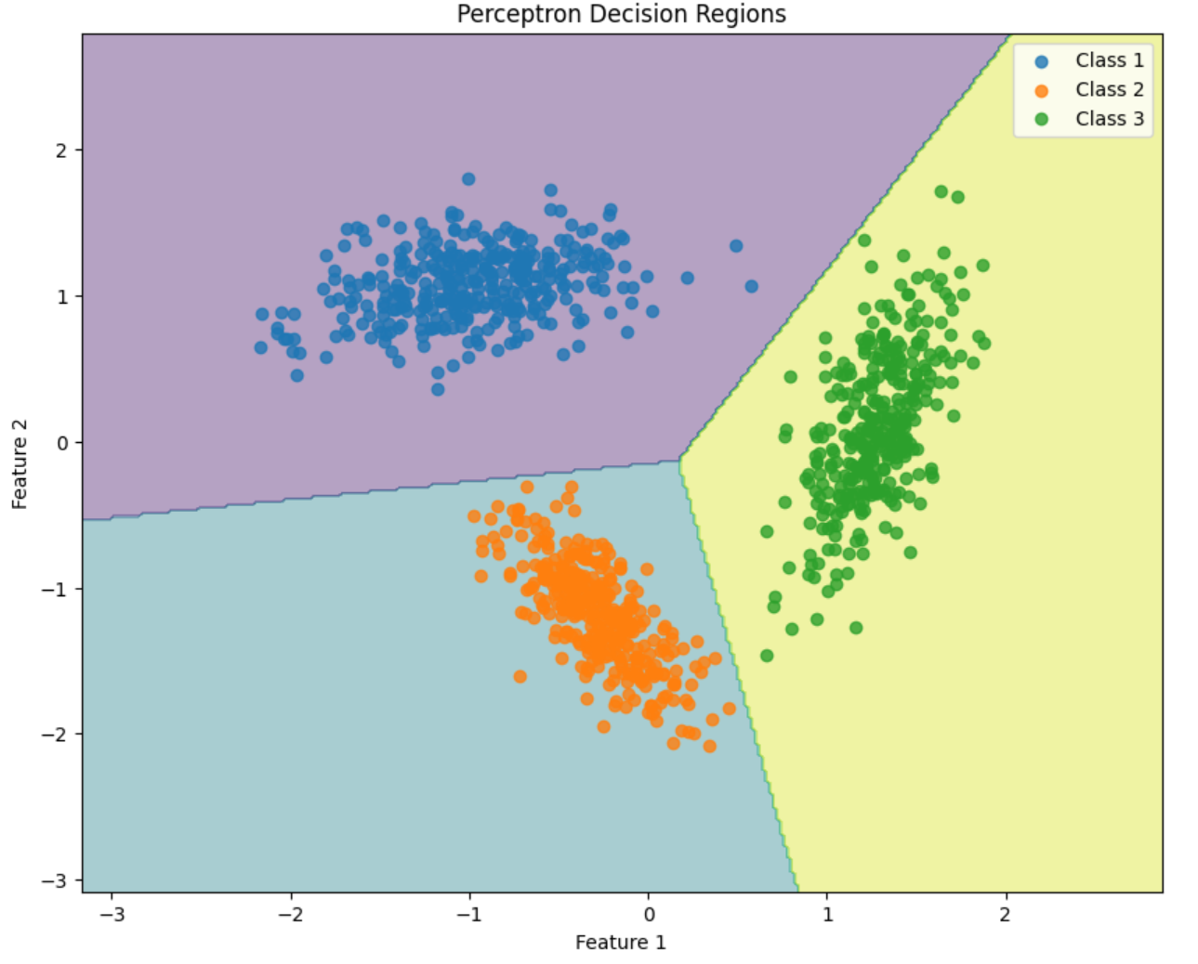
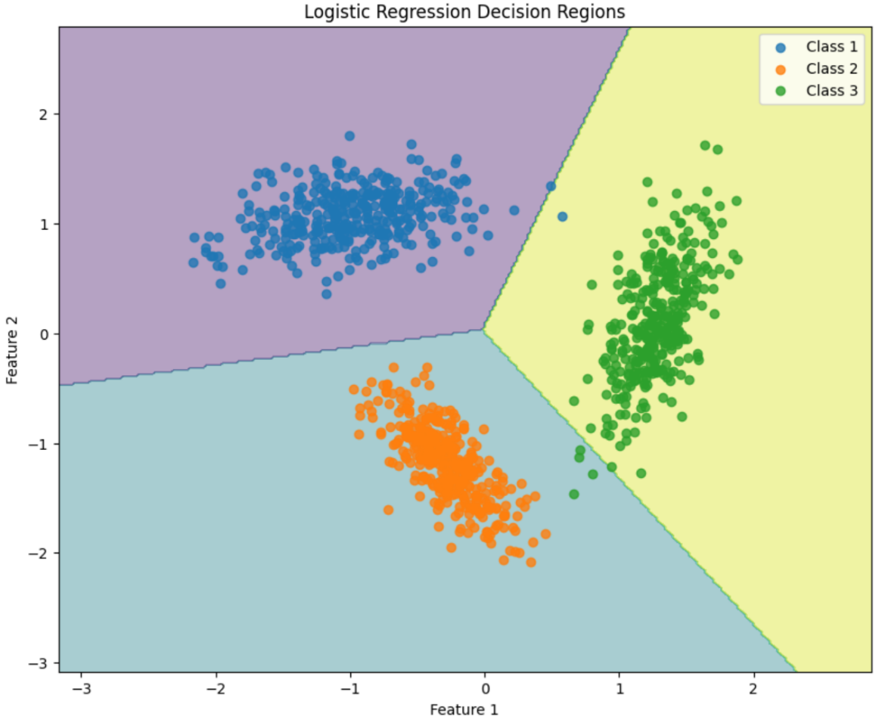
Figure 5 Perceptron Decision Regions
Figure 6 Logistic Regression Decision Regions
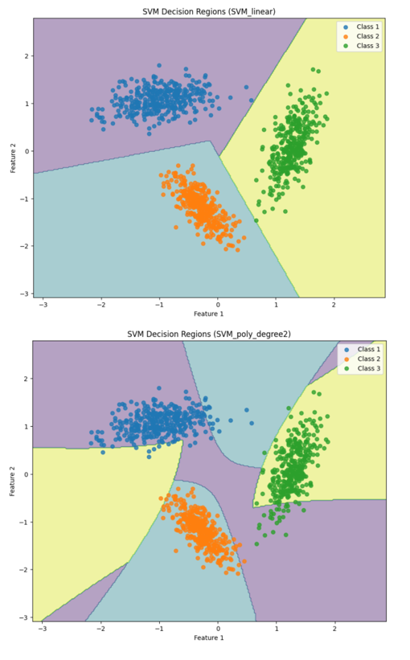
Figure 7 SVM Decision Regions
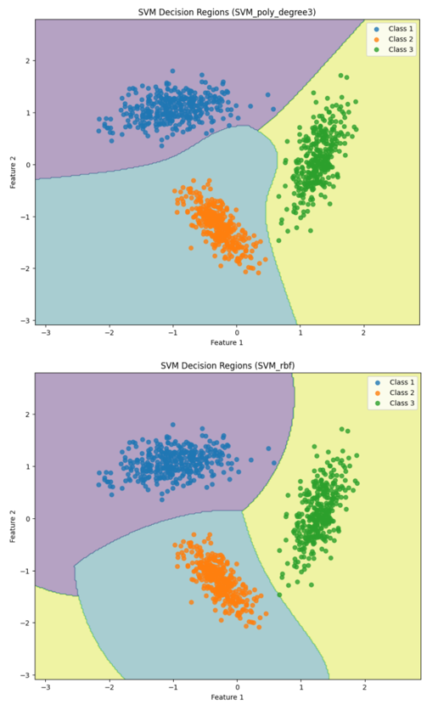
Figure 8 SVM Decision Regions

C. Plot Visualizations for Non-Linearly Separable Dataset
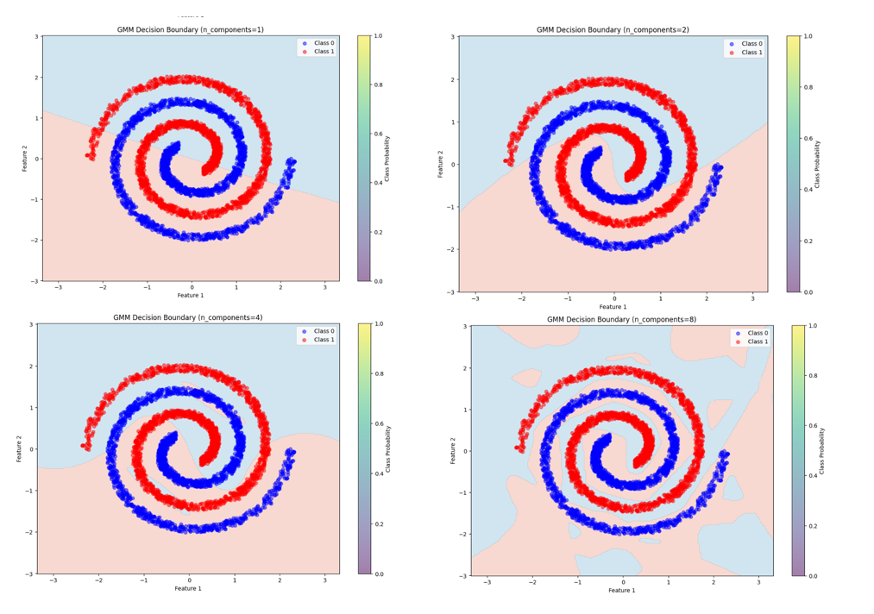
Figure 9 GMM Based Classifier Decision Regions for Components 1 to 8

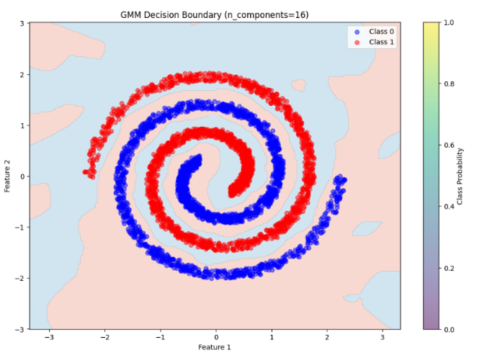
Figure 10 GMM Based Classifier Decision Regions for Components 16

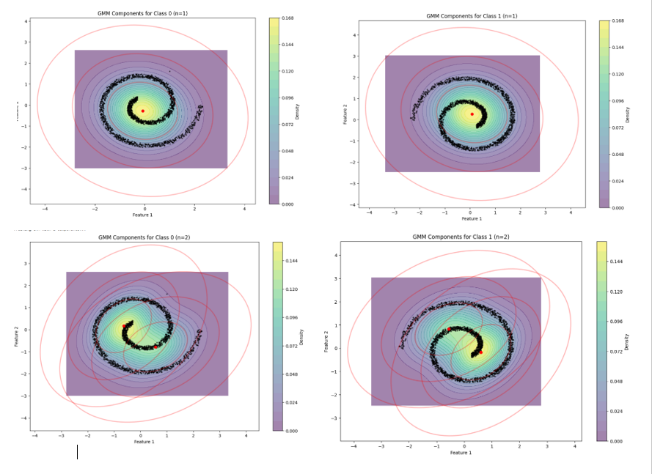
Figure 11 GMM Cluster centers for GMM Components 1 to 2
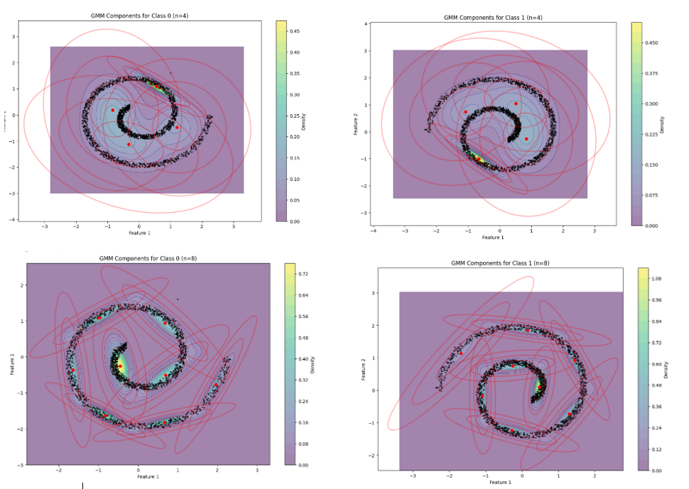
Figure 12 GMM Cluster centers for GMM Components 4 to 8
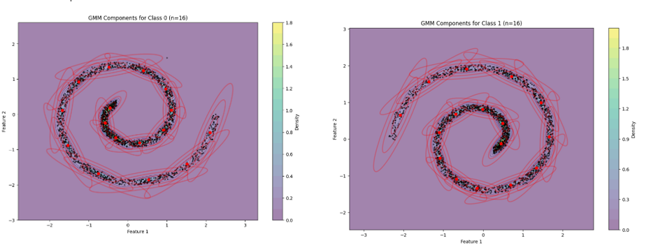
Figure 13 GMM Cluster centers for GMM Components 16

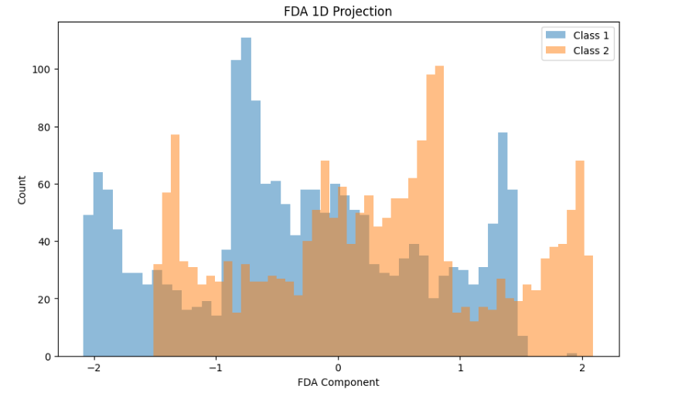
Figure 14 FDA 1D Projection
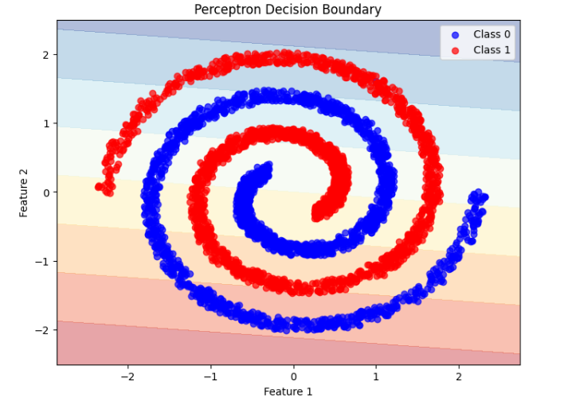
Figure 15 Perceptron Decision Boundary

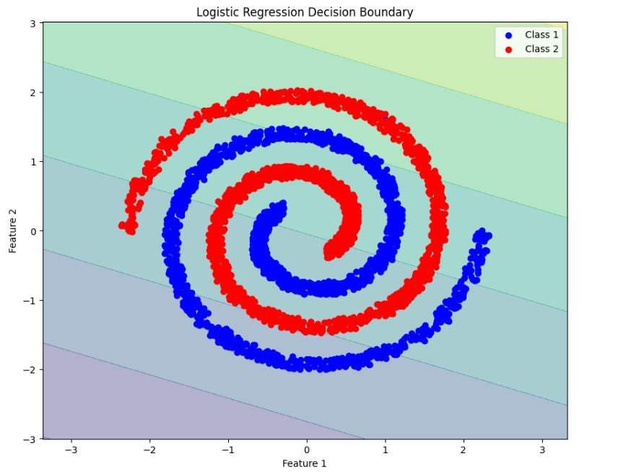
Figure 16 Logistic Regression Decision Boundary

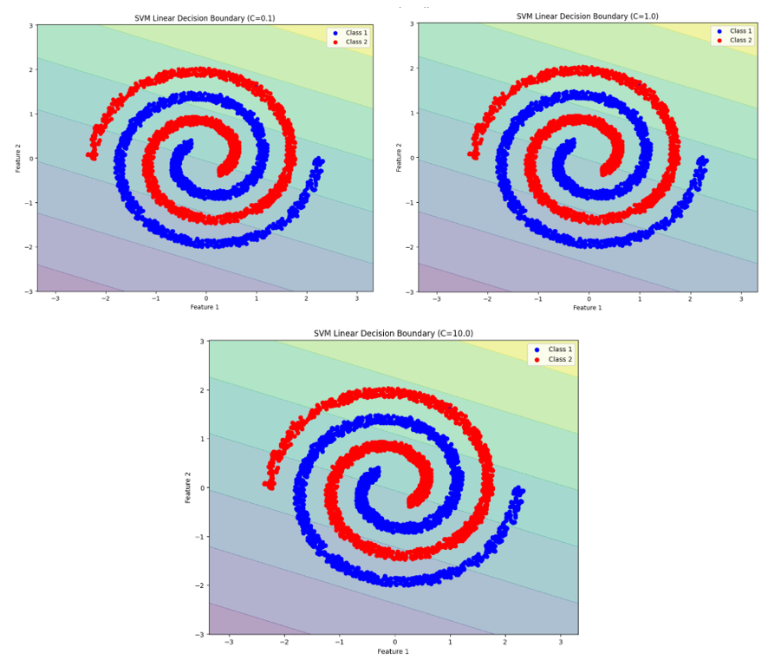
Figure 17 SVM Linear Decision Boundary

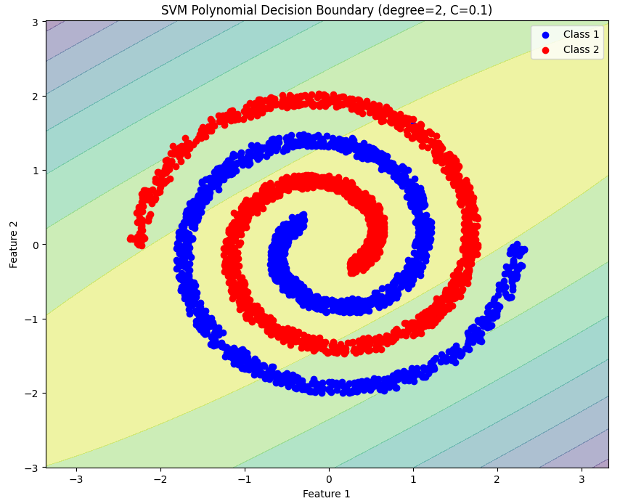
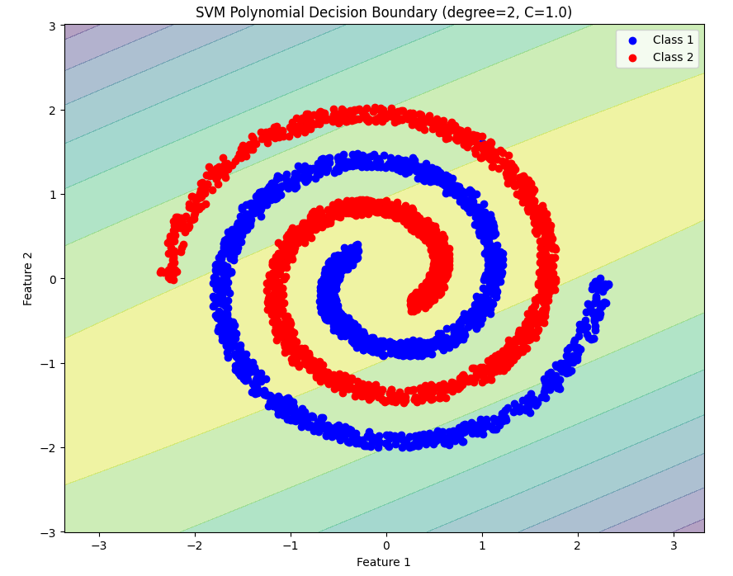
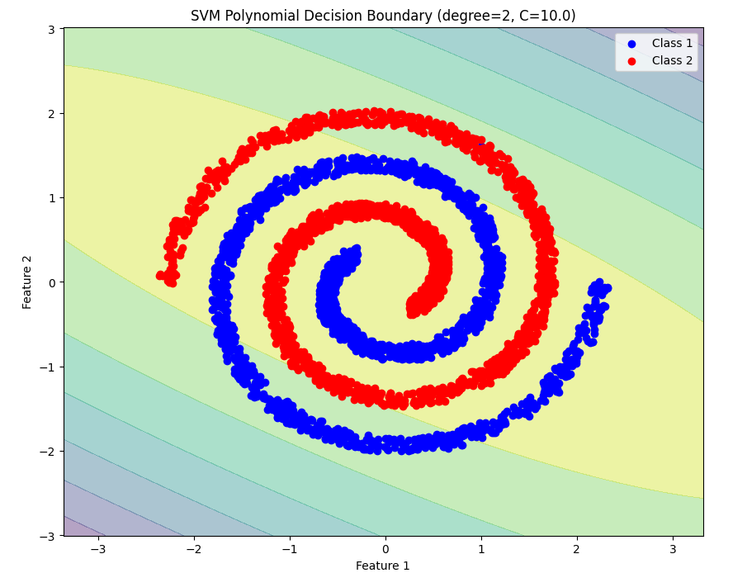
Figure 18 SVM Polynomial Decision Boundary for Degree = 2

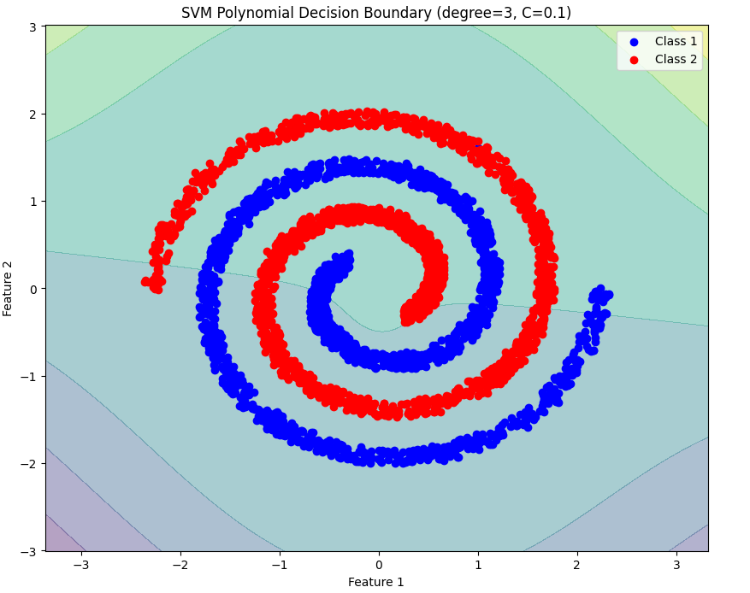
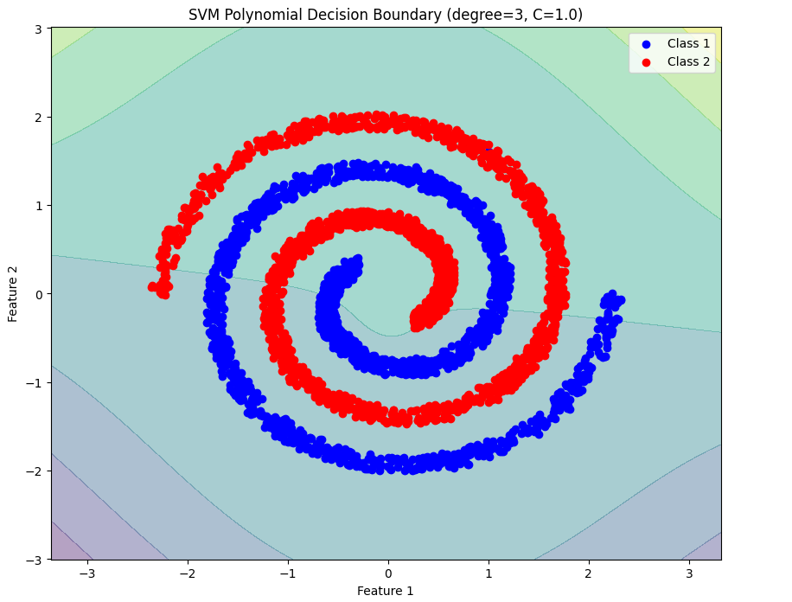
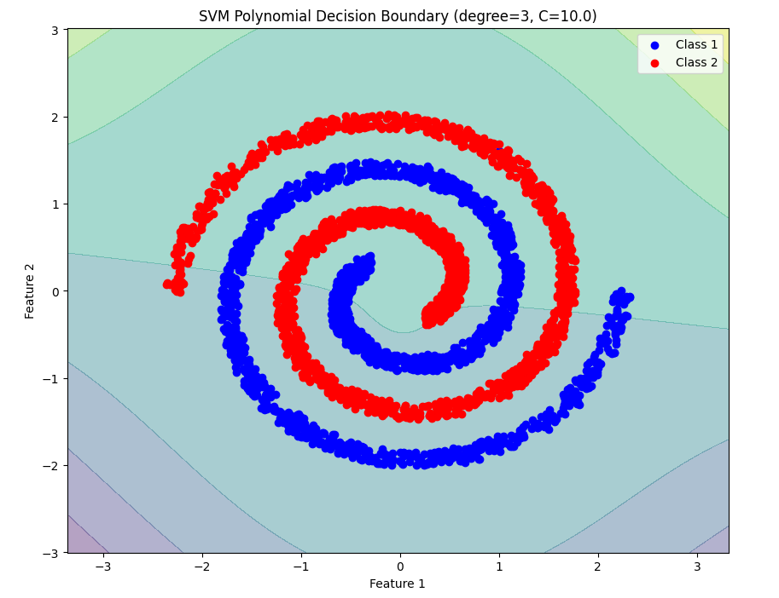
Figure 19 SVM Polynomial Decision Boundary for Degree = 3

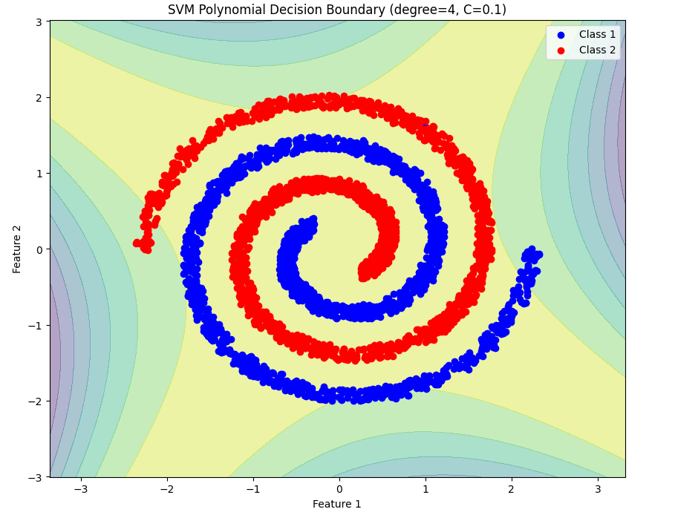
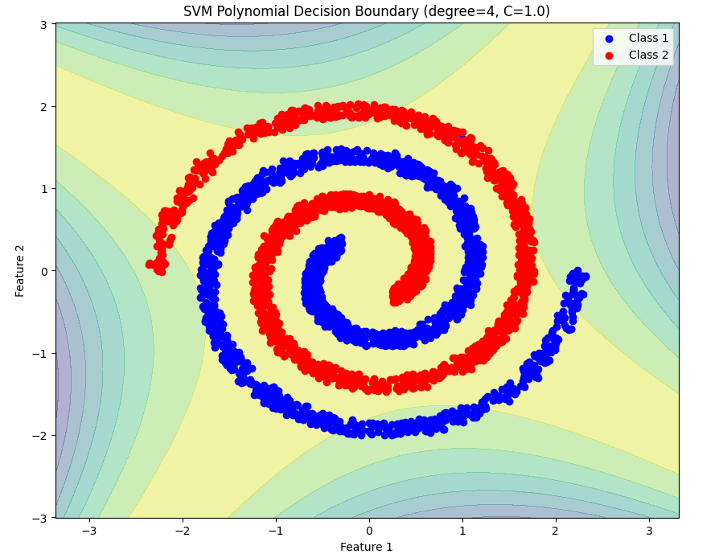
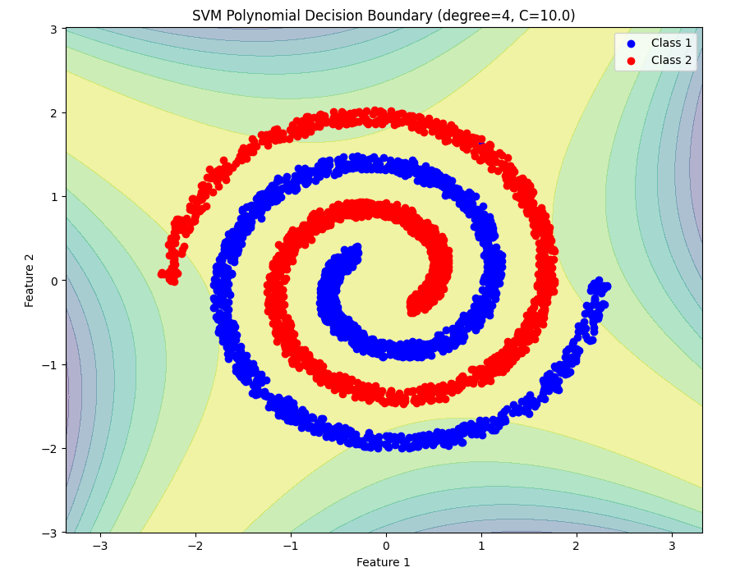
Figure 20 SVM Polynomial Decision Boundary for Degree = 4

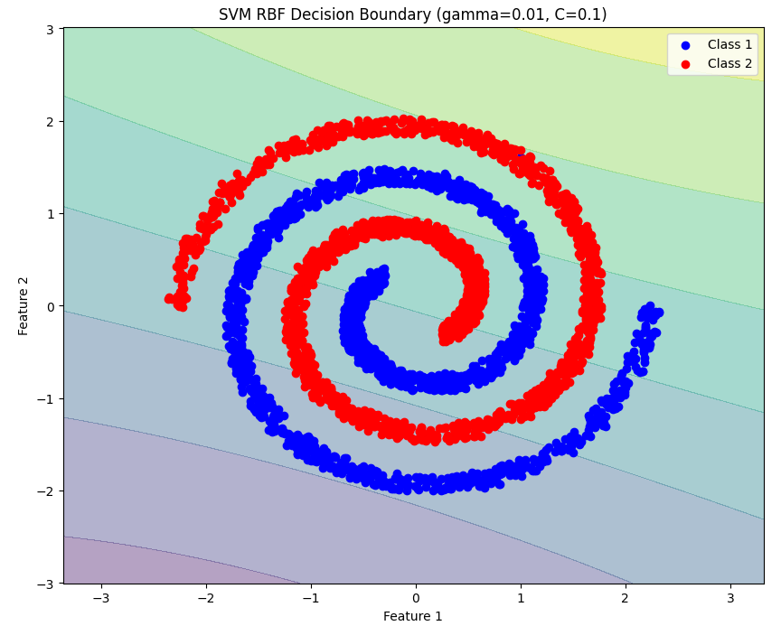
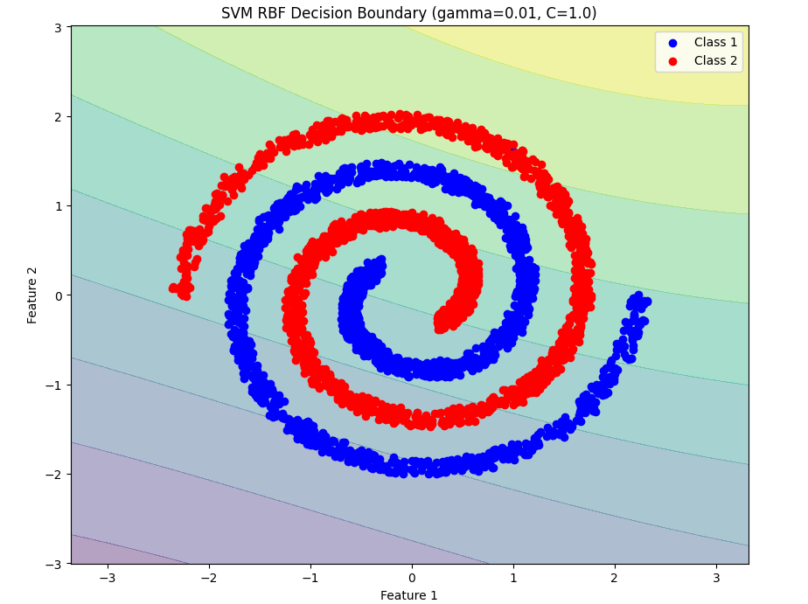
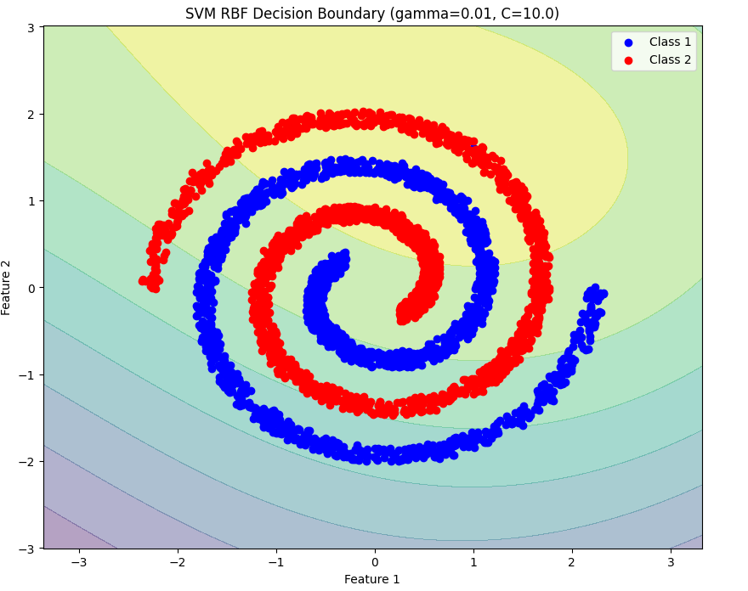
Figure 21 SVM RBF Decision Boundary (gamma =0.01)

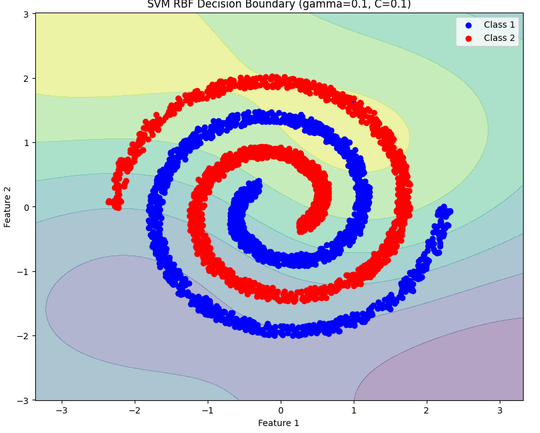
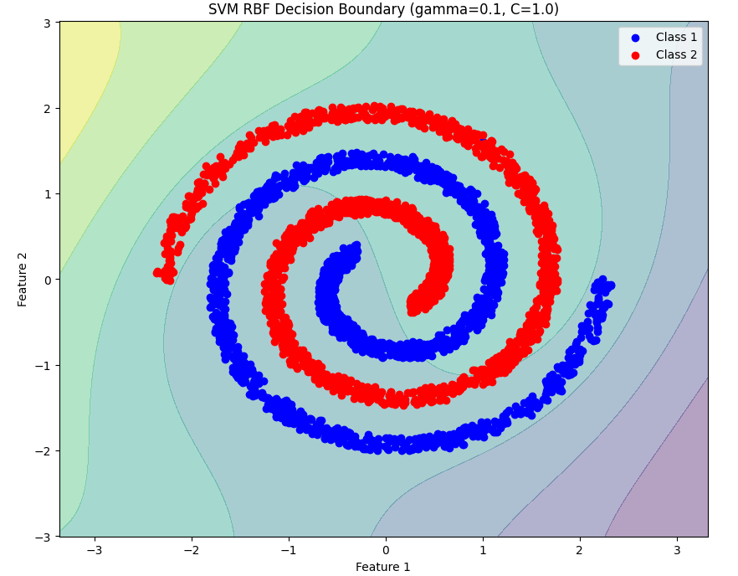
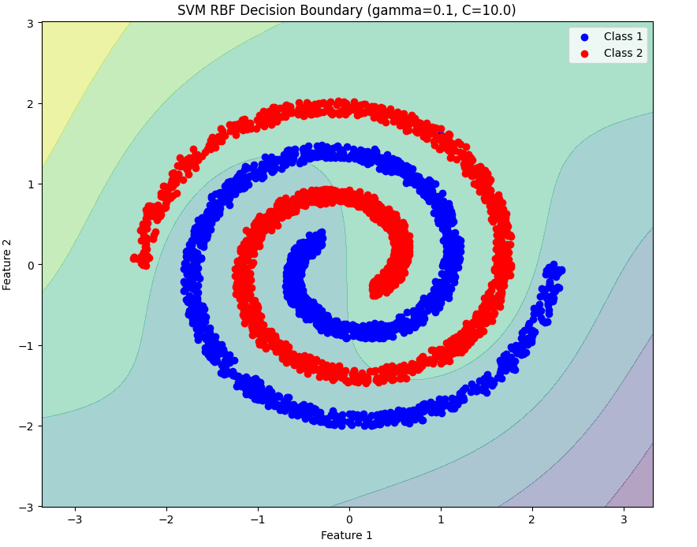
Figure 22 SVM RBF Decision Boundary (gamma =0.1)

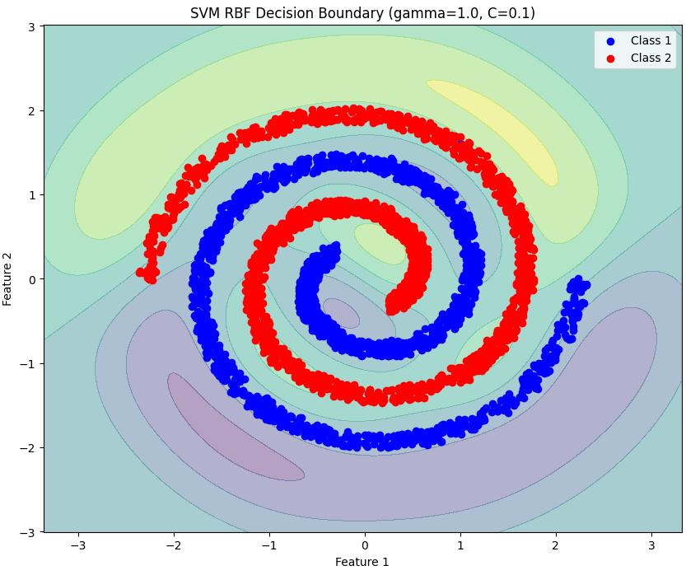
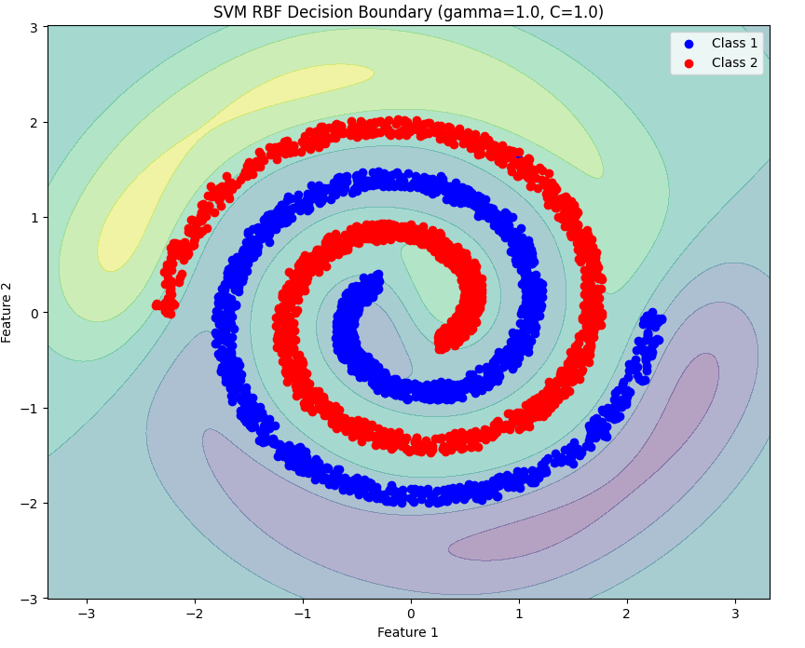
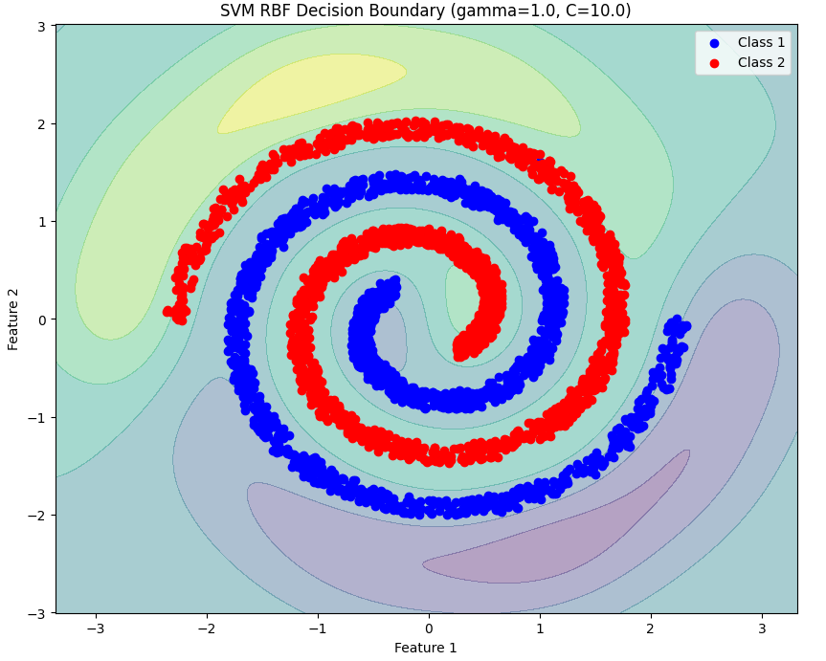
Figure 23 SVM RBF Decision Boundary (gamma =1)

D. Results and Analysis

1. Classifier Performance Metrics for Linearly Separable dataset
Confusion Matrix and Analysis: GMM-based Bayes Classifiers GMM with 1,2,4,8 components:

Actual  Predicted Class1 Class2 Class3  Class1 150 0 0  Class2 0 150 0  Class3 0 0 150  Table 1:Confusion Matrix | Class1 Class2 Class3  Precision 1.0000 1.0000 1.0000  Recall 1.0000 1.0000 1.0000  F-Measure 1.0000 1.0000 1.0000  Table 2:Analysis

Accuracy | 1.0000
Mean Precision | 1.0000
Mean Recall | 1.0000
Mean F-Measure | 1.0000
Table 3:Result
Confusion Matrix and Analysis: KNN-based Bayes Classifiers KNN with K=1 ,3,5,7 :

Actual  Predicted Class1 Class2 Class3  Class1 150 0 0  Class2 0 150 0  Class3 0 0 150  Table 4:Confusion Matrix | Class1 Class2 Class3  Precision 1.0000 1.0000 1.0000  Recall 1.0000 1.0000 1.0000  F-Measure 1.0000 1.0000 1.0000  Table 5:Analysis

Accuracy | 1.0000
Mean Precision | 1.0000
Mean Recall | 1.0000
Mean F-Measure | 1.0000
Table 6:Result
Confusion Matrix and Analysis: FDA-based Bayes Classifiers FDA with Gaussian assumption:
Actual  Predicted Class1 Class2 Class3  Class1 150 0 0  Class2 0 150 0  Class3 0 0 150  Table 7:Confusion Matrix | Class1 Class2 Class3  Precision 1.0000 1.0000 1.0000  Recall 1.0000 1.0000 1.0000  F-Measure 1.0000 1.0000 1.0000  Table 8:Analysis

Accuracy | 1.0000
Mean Precision | 1.0000
Mean Recall | 1.0000
Mean F-Measure | 1.0000
Table 9:Result
Confusion Matrix and Analysis: FDA-based Bayes Classifiers FDA with GMM:

Actual  Predicted Class1 Class2 Class3  Class1 150 0 0  Class2 0 150 0  Class3 0 0 150  Table 40:Confusion Matrix | Class1 Class2 Class3  Precision 1.0000 1.0000 1.0000  Recall 1.0000 1.0000 1.0000  F-Measure 1.0000 1.0000 1.0000  Table 11:Analysis

Accuracy | 1.0000
Mean Precision | 1.0000
Mean Recall | 1.0000
Mean F-Measure | 1.0000
Table 15:Result
Confusion Matrix and Analysis: Multiclass Perceptron Classifiers:

Actual  Predicted Class1 Class2 Class3  Class1 150 0 0  Class2 1 149 0  Class3 0 0 150  Table 64:Confusion Matrix | Class1 Class2 Class3  Precision 0.9934 1.0000 1.0000  Recall 1.0000 0.9933 1.0000  F-Measure 0.9967 0.9967 1.0000  Table 15:Analysis

Accuracy | 0.9978
Mean Precision | 0.9978
Mean Recall | 0.9978
Mean F-Measure | 0.9978
Table 16:Result

Confusion Matrix and Analysis: Multiclass Logistic Regression:

Actual  Predicted Class1 Class2 Class3  Class1 150 0 0  Class2 0 150 0  Class3 0 1 149  Table 77:Confusion Matrix | Class1 Class2 Class3  Precision 1.0000 0.9934 1.0000  Recall 1.0000 1.0000 0.9933  F-Measure 1.0000 0.9967 0.9967  Table 18:Analysis

Accuracy | 0.9978
Mean Precision | 0.9978
Mean Recall | 0.9978
Mean F-Measure | 0.9978
Table 19:Result

Confusion Matrix and Analysis: SVM Linear Classifiers:

Actual  Predicted Class1 Class2 Class3  Class1 150 0 0  Class2 0 150 0  Class3 0 0 150  Table 20:Confusion Matrix | Class1 Class2 Class3  Precision 1.0000 1.0000 1.0000  Recall 1.0000 1.0000 1.0000  F-Measure 1.0000 1.0000 1.0000  Table 81:Analysis

Accuracy | 1.0000
Mean Precision | 1.0000
Mean Recall | 1.0000
Mean F-Measure | 1.0000
Table 29:Result

Confusion Matrix and Analysis: SVM Poly_degree2 Classifiers:

Actual  Predicted Class1 Class2 Class3  Class1 139 3 8  Class2 0 148 2  Class3 0 0 140  Table 24:Confusion Matrix | Class1 Class2 Class3  Precision 0.9329 0.9801 0.9333  Recall 0.9267 0.9867 0.9333  F-Measure 0.9298 0.9834 0.9333  Table 105:Analysis

Accuracy | 0.9489
Mean Precision | 0.9488
Mean Recall | 0.9489
Mean F-Measure | 0.9488
Table 26:Result

Confusion Matrix and Analysis: SVM Poly_degree3 Classifiers:

Actual  Predicted Class1 Class2 Class3  Class1 150 0 0  Class2 0 150 0  Class3 0 0 150  Table 27:Confusion Matrix | Class1 Class2 Class3  Precision 1.0000 1.0000 1.0000  Recall 1.0000 1.0000 1.0000  F-Measure 1.0000 1.0000 1.0000  Table 118:Analysis

Accuracy | 1.0000
Mean Precision | 1.0000
Mean Recall | 1.0000
Mean F-Measure | 1.0000
Table 29:Result
Confusion Matrix and Analysis: SVM_rbf Classifiers:

Actual  Predicted Class1 Class2 Class3  Class1 150 0 0  Class2 0 150 0  Class3 0 0 150  Table 30:Confusion Matrix | Class1 Class2 Class3  Precision 1.0000 1.0000 1.0000  Recall 1.0000 1.0000 1.0000  F-Measure 1.0000 1.0000 1.0000  Table 31:Analysis

Accuracy | 1.0000
Mean Precision | 1.0000
Mean Recall | 1.0000
Mean F-Measure | 1.0000
Table 122:Result

2. Classifier Performance Metrics for Non Linearly Separable dataset
Confusion Matrix and Analysis: GMM-based Bayes Classifiers GMM with 1 component:

Predicted  Actual Class1 Class2  Class1 314 201  Class2 162 302  Table 33:Confusion Matrix | Class1 Class2  Precision 0.6597 0.6004  Recall 0.6097 0.6509  F-Measure 0.6337 0.6246  Table 34:Analysis

Accuracy | 0.6292
Mean Precision | 0.6300
Mean Recall | 0.6303
Mean F-Measure | 0.6291
Table 135:Result
Confusion Matrix and Analysis: GMM-based Bayes Classifiers GMM with 2 components:

Predicted  Actual Class1 Class2  Class1 324 191  Class2 150 314  Table 36:Confusion Matrix | Class1 Class2  Precision 0.6835 0.6218  Recall 0.6291 0.6767  F-Measure 0.6552 0.6481  Table 37:Analysis

Accuracy | 0.6517
Mean Precision
Mean Recall
Mean F-Measure
Table 148:Result

Confusion Matrix and Analysis: GMM-based Bayes Classifiers GMM with 4 components:

Predicted  Actual Class1 Class2  Class1 360 155  Class2 135 329  Table 39:Confusion Matrix | Class1 Class2  Precision 0.7273 0.6798  Recall 0.6990 0.7091  F-Measure 0.7129 0.6941  Table 40:Analysis

Accuracy | 0.7038
Mean Precision
Mean Recall
Mean F-Measure
Table 41:Result

Confusion Matrix and Analysis: GMM-based Bayes Classifiers GMM with 8 components:

Predicted  Actual Class1 Class2  Class1 515 0  Class2 5 459  Table 42:Confusion Matrix | Class1 Class2  Precision 0.9904 1.0000  Recall 1.0000 0.9892  F-Measure 0.9952 0.9946  Table 43:Analysis

Accuracy | 0.9949
Mean Precision
Mean Recall
Mean F-Measure
Table 44:Result

Confusion Matrix and Analysis: GMM-based Bayes Classifiers GMM with 16 components:

Predicted  Actual Class1 Class2  Class1 515 0  Class2 0 464  Table 45:Confusion Matrix | Class1 Class2  Precision 1.0000 1.0000  Recall 1.0000 1.0000  F-Measure 1.0000 1.0000  Table 46:Analysis

Accuracy | 1.0000
Mean Precision | 1.0000
Mean Recall | 1.0000
Mean F-Measure | 1.0000
Table 47:Result
Confusion Matrix and Analysis: KNN-based Bayes Classifiers KNN with K= 1:

Predicted  Actual Class1 Class2  Class1 374 141  Class2 110 354  Table 48:Confusion Matrix | Class1 Class2  Precision 0.7727 0.7152  Recall 0.7262 0.7629  F-Measure 0.7487 0.7383  Table 49:Analysis

Accuracy | 0.7436
Mean Precision
Mean Recall
Mean F-Measure
Table 50:Result
Confusion Matrix and Analysis: KNN-based Bayes Classifiers KNN with K= 3:

Predicted  Actual Class1 Class2  Class1 313 202  Class2 158 306  Table 515:Confusion Matrix | Class1 Class2  Precision 0.6645 0.6024  Recall 0.6078 0.6595  F-Measure 0.6349 0.6296  Table 516:Analysis

Accuracy | 0.6323
Mean Precision
Mean Recall
Mean F-Measure
Table 517:Result

Confusion Matrix and Analysis: KNN-based Bayes Classifiers KNN with K= 5:

Predicted  Actual Class1 Class2  Class1 310 205  Class2 160 304  Table 54:Confusion Matrix | Class1 Class2  Precision 0.6596 0.5972  Recall 0.6019 0.6552  F-Measure 0.6294 0.6249  Table 55:Analysis

Accuracy | 0.6272
Mean Precision
Mean Recall
Mean F-Measure
Table 56:Result
Confusion Matrix and Analysis: KNN-based Bayes Classifiers KNN with K= 7:

Predicted  Actual Class1 Class2  Class1 313 202  Class2 161 303  Table 57:Confusion Matrix | Class1 Class2  Precision 0.6603 0.6000  Recall 0.6078 0.6530  F-Measure 0.6330 0.6254  Table 58:Analysis

Accuracy | 0.6292
Mean Precision
Mean Recall
Mean F-Measure
Table 59:Result
Confusion Matrix and Analysis: FDA-based Bayes Classifiers FDA with Gaussian assumption:

Predicted  Actual Class1 Class2  Class1 302 213  Class2 156 308  Table 60:Confusion Matrix | Class1 Class2  Precision 0.6594 0.5912  Recall 0.5864 0.6638  F-Measure 0.6208 0.6264  Table 61:Analysis

Accuracy | 0.6231
Mean Precision
Mean Recall
Mean F-Measure
Table 62:Result
Confusion Matrix and Analysis: FDA-based Bayes Classifiers FDA with GMM(components=1):

Predicted  Actual Class1 Class2  Class1 314 201  Class2 162 302  Table 63:Confusion Matrix | Class1 Class2  Precision 0.6597 0.6004  Recall 0.6097 0.6509  F-Measure 0.6337 0.6246  Table 64:Analysis

Accuracy | 0.6292
Mean Precision
Mean Recall
Mean F-Measure
Table 65:Result
Confusion Matrix and Analysis: FDA-based Bayes Classifiers FDA with GMM(components=2):

Predicted  Actual Class1 Class2  Class1 293 222  Class2 135 339  Table 66:Confusion Matrix | Class1 Class2  Precision 0.6846 0.5971  Recall 0.5689 0.7091  F-Measure 0.6214 0.6483  Table 67:Analysis

Accuracy | 0.6393
Mean Precision
Mean Recall
Mean F-Measure
Table 68:Result

Confusion Matrix and Analysis: FDA-based Bayes Classifiers FDA with GMM(components=4):

Predicted  Actual Class1 Class2  Class1 350 165  Class2 123 341  Table 69:Confusion Matrix | Class1 Class2  Precision 0.7400 0.6739  Recall 0.6796 0.7349  F-Measure 0.7085 0.7031  Table 70:Analysis

Accuracy | 0.7058
Mean Precision
Mean Recall
Mean F-Measure
Table 71:Result

Confusion Matrix and Analysis: FDA-based Bayes Classifiers FDA with GMM(components=8):

Predicted  Actual Class1 Class2  Class1 355 160  Class2 133 331  Table 72:Confusion Matrix | Class1 Class2  Precision 0.7275 0.6741  Recall 0.6893 0.7134  F-Measure 0.7079 0.6932  Table 73:Analysis

Accuracy | 0.7007
Mean Precision
Mean Recall
Mean F-Measure
Table 74:Result

Confusion Matrix and Analysis: Multiclass Perceptron Classifiers:

Predicted  Actual Class1 Class2  Class1 79 436  Class2 3 461  Table 75:Confusion Matrix | Class1 Class2  Precision 0.9634 0.5139  Recall 0.1534 0.9935  F-Measure 0.2647 0.6774  Table 76:Analysis

Accuracy | 0.5516
Mean Precision
Mean Recall
Mean F-Measure
Table 77:Result

Confusion Matrix and Analysis: Multiclass Logistic Regression:

Predicted  Actual Class1 Class2  Class1 302 213  Class2 156 308  Table 78:Confusion Matrix | Class1 Class2  Precision 0.6594 0.5912  Recall 0.5864 0.6638  F-Measure 0.6208 0.6254  Table 79:Analysis

Accuracy | 0.6231
Mean Precision
Mean Recall
Mean F-Measure
Table 80:Result

Confusion Matrix and Analysis: SVM Linear Classifiers(c=0.1):

Predicted  Actual Class1 Class2  Class1 300 215  Class2 154 310  Table 81:Confusion Matrix | Class1 Class2  Precision 0.6608 0.5905  Recall 0.5825 0.6681  F-Measure 0.6192 0.6269  Table 818:Analysis

Accuracy | 0.6231
Mean Precision
Mean Recall
Mean F-Measure
Table 819:Result

Confusion Matrix and Analysis: SVM Linear Classifiers(c=1):

Predicted  Actual Class1 Class2  Class1 301 214  Class2 154 310  Table 84:Confusion Matrix | Class1 Class2  Precision 0.6615 0.5916  Recall 0.5845 0.6681  F-Measure 0.6206 0.6275  Table 85:Analysis

Accuracy | 0.6241
Mean Precision
Mean Recall
Mean F-Measure
Table 86:Result

Confusion Matrix and Analysis: SVM Linear Classifiers(c=10):

Predicted  Actual Class1 Class2  Class1 301 214  Class2 154 310  Table 87:Confusion Matrix | Class1 Class2  Precision 0.6615 0.5916  Recall 0.5845 0.6681  F-Measure 0.6206 0.6275  Table 88:Analysis

Accuracy | 0.6241
Mean Precision
Mean Recall
Mean F-Measure
Table 89:Result

Confusion Matrix and Analysis: SVM Poly_degree2 Classifiers(c= 0.1 , 1 , 10):

Predicted  Actual Class1 Class2  Class1 0 515  Class2 0 464  Table 90:Confusion Matrix | Class1 Class2  Precision 0.0000 0.4740  Recall 0.0000 1.0000  F-Measure 0.0000 0.6231  Table 91:Analysis

Accuracy | 0.4740
Mean Precision
Mean Recall
Mean F-Measure
Table 92:Result

Confusion Matrix and Analysis: SVM Poly_degree3 Classifiers (c=0.1) :

Predicted  Actual Class1 Class2  Class1 305 210  Class2 127 337  Table 93:Confusion Matrix | Class1 Class2  Precision 0.7060 0.6161  Recall 0.5922 0.7263  F-Measure 0.6441 0.6667  Table 94:Analysis

Accuracy | 0.6558
Mean Precision
Mean Recall
Mean F-Measure
Table 95:Result
Confusion Matrix and Analysis: SVM Poly_degree3 Classifiers (c=1 , 10) :

Predicted  Actual Class1 Class2  Class1 305 210  Class2 128 336  Table 96:Confusion Matrix | Class1 Class2  Precision 0.7044 0.6154  Recall 0.5922 0.7241  F-Measure 0.6435 0.6653  Table 98:Analysis

Accuracy | 0.6547
Mean Precision
Mean Recall
Mean F-Measure
Table 99:Result
Confusion Matrix and Analysis: SVM Poly_degree4 Classifiers (c=0.1) :

Predicted  Actual Class1 Class2  Class1 20 495  Class2 39 425  Table 100:Confusion Matrix | Class1 Class2  Precision 0.3390 0.4620  Recall 0.0388 0.9159  F-Measure 0.0697 0.6142  Table 101:Analysis

Accuracy | 0.4545
Mean Precision
Mean Recall
Mean F-Measure
Table 102:Result

Confusion Matrix and Analysis: SVM Poly_degree4 Classifiers (c=1) :

Predicted  Actual Class1 Class2  Class1 38 477  Class2 56 408  Table 103:Confusion Matrix | Class1 Class2  Precision 0.4043 0.4610  Recall 0.0738 0.8793  F-Measure 0.1248 0.6049  Table 104:Analysis

Accuracy | 0.4556
Mean Precision
Mean Recall
Mean F-Measure
Table 105:Result

Confusion Matrix and Analysis: SVM Poly_degree4 Classifiers (c=10) :

Predicted  Actual Class1 Class2  Class1 39 476  Class2 56 408  Table 106:Confusion Matrix | Class1 Class2  Precision 0.4105 0.4615  Recall 0.0757 0.8793  F-Measure 0.1279 0.6053  Table 107:Analysis

Accuracy | 0.4566
Mean Precision
Mean Recall
Mean F-Measure
Table 108:Result

Confusion Matrix and Analysis: SVM_rbf Classifiers( gamma=0.01, C=0.1):

Predicted  Actual Class1 Class2  Class1 300 215  Class2 155 309  Table 109:Confusion Matrix | Class1 Class2  Precision 0.6593 0.5897  Recall 0.5825 0.6659  F-Measure 0.6186 0.6255  Table 110:Analysis

Accuracy | 0.6221
Mean Precision
Mean Recall
Mean F-Measure
Table 112:Result
Confusion Matrix and Analysis: SVM_rbf Classifiers( gamma=0.01, C=1):

Predicted  Actual Class1 Class2  Class1 293 222  Class2 138 326  Table 113:Confusion Matrix | Class1 Class2  Precision 0.6798 0.5949  Recall 0.5689 0.7026  F-Measure 0.6195 0.6443  Table 114:Analysis

Accuracy | 0.6323
Mean Precision
Mean Recall
Mean F-Measure
Table 115:Result

Confusion Matrix and Analysis: SVM_rbf Classifiers( gamma=0.01, C=10):

Predicted  Actual Class1 Class2  Class1 222 293  Class2 114 350  Table 116:Confusion Matrix | Class1 Class2  Precision 0.6607 0.5443  Recall 0.4311 0.7543  F-Measure 0.5217 0.6323  Table 117:Analysis

Accuracy | 0.5843
Mean Precision
Mean Recall
Mean F-Measure
Table 118:Result

Confusion Matrix and Analysis: SVM_rbf Classifiers( gamma=0.1, C=0.1):

Predicted  Actual Class1 Class2  Class1 283 232  Class2 125 339  Table 119:Confusion Matrix | Class1 Class2  Precision 0.6636 0.5937  Recall 0.5495 0.7306  F-Measure 0.6132 0.6551  Table 120:Analysis

Accuracy | 0.6353
Mean Precision
Mean Recall
Mean F-Measure
Table 121:Result

Confusion Matrix and Analysis: SVM_rbf Classifiers( gamma=0.1, C=1):

Predicted  Actual Class1 Class2  Class1 341 274  Class2 135 329  Table 122:Confusion Matrix | Class1 Class2  Precision 0.7164 0.6541  Recall 0.6621 0.7091  F-Measure 0.6882 0.6805  Table 123:Analysis

Accuracy | 0.6844
Mean Precision
Mean Recall
Mean F-Measure
Table 124:Result

Confusion Matrix and Analysis: SVM_rbf Classifiers( gamma=0.1, C=10):

Predicted  Actual Class1 Class2  Class1 358 157  Class2 128 336  Table 125:Confusion Matrix | Class1 Class2  Precision 0.7366 0.6815  Recall 0.6951 0.7241  F-Measure 0.7153 0.7022  Table 126:Analysis

Accuracy | 0.7089
Mean Precision
Mean Recall
Mean F-Measure
Table 127:Result

Confusion Matrix and Analysis: SVM_rbf Classifiers( gamma=1, C=0.1):

Predicted  Actual Class1 Class2  Class1 453 62  Class2 39 425  Table 128:Confusion Matrix | Class1 Class2  Precision 0.9207 0.8727  Recall 0.8796 0.9159  F-Measure 0.8997 0.8938  Table 129:Analysis

Accuracy | 0.8968
Mean Precision
Mean Recall
Mean F-Measure
Table 130:Result

Confusion Matrix and Analysis: SVM_rbf Classifiers( gamma=1, C=1):

Predicted  Actual Class1 Class2  Class1 512 3  Class2 0 464  Table 131:Confusion Matrix | Class1 Class2  Precision 1.0000 0.9936  Recall 0.9942 1.0000  F-Measure 0.9971 0.9968  Table 132:Analysis

Accuracy | 0.9969
Mean Precision
Mean Recall
Mean F-Measure
Table 133:Result

Confusion Matrix and Analysis: SVM_rbf Classifiers( gamma=1, C=10):

Predicted  Actual Class1 Class2  Class1 515 0  Class2 0 464  Table 134:Confusion Matrix | Class1 Class2  Precision 1.0000 1.0000  Recall 1.0000 1.0000  F-Measure 1.0000 1.0000  Table 135:Analysis

Accuracy | 1.0000
Mean Precision | 1.0000
Mean Recall | 1.0000
Mean F-Measure | 1.0000
Table 136:Result

  - Classification accuracy.
  - Per-class and mean precision, recall, and F-measure.
  - Confusion matrices for test datasets.

2. KNN-Based Bayes Classifier Analysis
- Observations:
  - Increasing KKK resulted in smoother decision boundaries but reduced flexibility.
  - Optimal performance observed at K=3K=3K=3.

3. FDA Analysis
- Unimodal Gaussian:
  - Performed well on linearly separable data but struggled with nonlinear patterns.
- GMM:
  - Improved flexibility, capturing non-linear class structures effectively.

4. Perceptron Analysis
- Convergence was achieved faster for linearly separable data.
- Performance declined significantly on nonlinearly separable data.

5. Logistic Regression Analysis
- Showed competitive performance with smooth decision boundaries.
- Regularization helped control overfitting on nonlinear data.

6. SVM Analysis
- Kernel Comparisons:
  - Linear kernel excelled on linearly separable data.
  - Gaussian kernel outperformed on non-linear data, especially with optimized bandwidth.
  - Polynomial kernel provided a balance for moderately non-linear data.
- Optimal parameters were determined through grid search.

C. Comparative Analysis

1. Decision Region Plots
- KNN, perceptron, logistic regression, and SVM boundaries compared visually.
- Highlighted differences in decision boundaries for various methods.

2. Special Comparisons
- Perceptron vs Linear SVM:
  - SVM showed superior generalization on test data.
- FDA Dimensionality Reduction:
  - Effectively reduced dimensions for visualization and improved classifier performance.

III. Dataset 2: 3-Class Scene Image Dataset

A. Methodology

1. Bayes Classifier Using GMM
- GMMs with 1, 2, 4, and 8 mixtures were applied to the 32-dimensional BoVW dataset reduced via PCA.
- PCA reduced the dataset dimensions to 2, 5, 10, 15, and 20, retaining significant variance.
- The classification was conducted on the reduced dataset using GMM, and the effects of varying mixtures and PCA dimensions were analyzed.

2. Bayes Classifier Using KNN
- Experimented with K=1,3,5K=1, 3, 5K=1,3,5 for density estimation.
- Performance trends were analyzed.

3. FDA Implementation
- Dimensionality reduction via FDA.
- Comparison of unimodal Gaussian and GMM-based classifiers.

4. Perceptron Implementation
- Adapted perceptron for multi-class classification.

5. Logistic Regression Implementation
- Extended logistic regression for multi-class classification.

6. SVM Implementation
- Implemented SVM with one-vs-one and one-vs-all strategies for multi-class classification.
- Kernel and parameter tuning.

B. Results and Analysis

1. Classifier Performance Metrics
- Accuracy, precision, recall, F-measure, and confusion matrices.

2. GMM Analysis
- Observed improved performance with increasing mixtures.
- PCA effectively reduced dimensionality without significant accuracy loss.

3. KNN Analysis
- K=3K=3K=3 provided optimal balance between flexibility and overfitting.

4. FDA Performance
- Enhanced class separability in reduced dimensions.

5. Perceptron and Logistic Regression Results
- Perceptron showed slower convergence for multi-class data.
- Logistic regression exhibited stable performance across all classes.

6. SVM Results
- Gaussian kernel provided the best performance.
- Multi-class strategies yielded comparable results.

C. Dimensionality Reduction Analysis

1. PCA Analysis
- Eigenvalue Distribution:
  - Demonstrated the significance of the first few principal components.
- 2D Representation:
  - Visualized class separability post-reduction.

2. FDA Analysis
- Improved discrimination between classes in reduced dimensions.

IV. Overall Comparative Analysis

A. Cross-Assignment Comparison
- Observed performance improvements over previous assignments due to advanced techniques.
- SVM and GMM consistently emerged as top-performing methods.

V. Conclusion

A. Key Findings
- SVM with Gaussian kernel and GMM-based classifiers outperformed others on non-linear data.
- Dimensionality reduction via PCA and FDA improved computational efficiency without sacrificing accuracy.

B. Best Performing Methods
- Dataset 1: SVM with RBF kernel.
- Dataset 2: GMM with PCA-based dimensionality reduction.

C. Analysis Insights
- Parameter tuning and dimensionality reduction are crucial for high-dimensional datasets.
- Non-linear models excel in capturing complex patterns.

VI. References
- Bishop, C. M. (2006). Pattern Recognition and Machine Learning. Springer.
- Duda, R. O., Hart, P. E., & Stork, D. G. (2000). Pattern Classification. Wiley.
- Murphy, K. P. (2012). Machine Learning: A Probabilistic Perspective. MIT Press.
- Mitchell, T. M. (1997). Machine Learning. McGraw-Hill.

